**Index**

|  |  |  |
| --- | --- | --- |
| **Sr.no** | **Title** | **Page no.** |
| **1** | **Introduction** |  |
| **1.1. Introduction of the project Weather App** |  |
| **1.2. Scope of work** |  |
| **1.3.Operating environment-Hardware and software** |  |
| **1.4.Module Description** |  |
| **1.5.Detail Description of technology used** |  |
| **2** | **Proposed System** |  |
| **2.1. Proposed System** |  |
| **2.2. Objectives of System** |  |
| **2.3. User Requirement** |  |
| **3** | **Analysis and Design** |  |
| **3.1. Class Diagram** |  |
| **3.2. Use Case Diagram** |  |
| **3.3. Activity Diagram** |  |
| **3.4. Data Dictionary** |  |
| **3.5.Test procedure and implementation** |  |
| **4** | **User Manual** |  |
| **5** | **Drawback and Limitations** |  |
| **6** | **Proposed Enhancements** |  |
| **7** | **User Interface Screens** |  |
| **8** | **Conclusion** |  |
| **9** | **Bibliography** |  |

**1. INTRODUCTION**

**1.1 Introduction to the project Weather App**

Weather forecasting is the application of science and technology to predict the conditions of the atmosphere for a given location and time. Weather forecasts are made by collecting quantitative data about the current state of the atmosphere at a given place and using meteorology to project how the atmosphere will change. The role of Technology has been remarkable in the field of weather forecasting. Weather data is not only necessary for researchers or scientists, ordinary people can be benefitted from it as well. People nowadays are feeling the necessity of weather data as well. There are a variety of weather mobile apps in Google Play and the App store.

1. **Real-Time Weather Data:** WeatherNow integrates with a powerful weather API to fetch real-time weather information for any location around the world. Get access to current weather conditions, forecasts, temperature, humidity, wind speed, and more.
2. **Registration and Login with Firebase:** We prioritize the security of your data. WeatherNow employs Firebase for user authentication and management. You can register a new account, log in securely.

**1.2 Scope Of Work**

1. **Basic Features:**
   * Current weather conditions (temperature, humidity, wind speed).
   * 3 to 7-day forecasts.
   * Sunrise and sunset times.
2. **Location Services:**
   * Geolocation for current weather.
   * Save multiple locations.
3. **User Personalization:**
   * User accounts for preferences.
   * Customizable notifications.
4. **Additional Features:**
   * Weather maps (radar, satellite).
   * Air Quality Index (AQI) and pollen count.
   * Widgets for home screens.
5. **Social Integration:**
   * Share weather updates.
   * Community features.
6. **Information :**
   * Weather-related news and articles.

**1.3 Operating Environment – Hardware and Software**

* **Hardware Requirements :**
* Processor 🡺 Intel Core i3
* Hard Disk 🡺 512GB
* RAM 🡺 4GB
* **Software Requirements :**
* Operating System 🡺 Windows 7 or later, macOS, Linux
* Frontend 🡺 Android Studio(XML,JAVA)
* Backend 🡺 Weather API and Firebase
* Tools/ IDE 🡺 Android Studio

**1.4 Module Description**

1. **Registration 🡺** Email, Password
2. **Login 🡺** Email, Password
3. **Weather API 🡺**

* **Location 🡺** Name , Latitude, Longitude
* **Current 🡺** Temperature

**Condition 🡺** Text, Icon

* **Forecast 🡺**

**Forecastday 🡺** Date

* **Hour 🡺** Time, Temperature , is_day

**Condition 🡺** Text, Icon, Wind

**1.4 Detail Description of technology Used**

**Frontend :**

1. **Java Language:** Android app development primarily relies on Java, a versatile, platform-independent programming language known for its portability and ease of use.
2. **Android Studio:** Developers use Android Studio as the official integrated development environment (IDE) for creating Android apps. It offers a suite of tools, including code editors and layout designers, to simplify the development process.

1. **XML Layouts and Views:** The app's user interface is defined using XML layout files, which include various views (e.g., buttons, text fields, images). XML files are linked to Java code to manage user interactions.

**Backend :**

**API (Application Programming Interface):** An API, or Application Programming Interface, is a set of rules and protocols that allows different software applications to communicate and interact with each other. APIs are crucial for enabling the integration of different systems, services, and applications. They serve as intermediaries that allow developers to harness the functionality of other software without needing to understand the intricacies of how that software works internally.

**Firebase:** Firebase is a comprehensive mobile and web application development platform provided by Google. It offers a set of tools and services that help developers build high-quality apps more efficiently.

Firebase simplifies many aspects of app development by offering a scalable, fully managed infrastructure for backend services. Developers can focus on building features and user experiences while Firebase handles the underlying infrastructure and server-side logic. It's a popular choice for startups and developers looking to accelerate app development without sacrificing quality and security

**2. PROPOSED SYSTEM**

* 1. **Proposed System**

**1. Frontend Development (Android Studio with XML and Java):**

**User Interface (UI) Design:**

* **XML Layouts:** Design various screens using XML layout files, defining the arrangement and appearance of UI elements.
* **Widgets and Views:** Implement interactive elements such as buttons, text views, and image views.
* **Resource Management:** Efficiently manage resources like images and strings.

**Networking and API Integration:**

* **HTTP Requests:** Use Java libraries or Android's built-in libraries for making HTTP requests to fetch weather data from the API.
* **AsyncTask/Thread Management:** Implement asynchronous tasks or threads to avoid blocking the UI thread during network calls.

**2. Backend Development (Firebase):**

**Firebase Setup:**

* **Firebase Console:** Set up a Firebase project through the Firebase console.
* **Authentication**: Implement Firebase Authentication for user registration and login.

**Realtime Database:**

* **Database Structure:** Design the Firebase Realtime Database structure to store user-specific data and preferences.
* **Integration:** Integrate Firebase SDK in the Android app for seamless data communication.

**Integration and Deployment:**

**Weather API Integration:**

* **API Key Handling:** Safely handle API keys using secure methods.
* **Retrofit or HTTP Library**: Use Retrofit or another HTTP library to interact with the weather API.

**Firebase and Weather API Integration:**

* **Data Synchronization:** Sync data between the Firebase Realtime Database and weather API responses.
* **Asynchronous Operations**: Manage asynchronous operations effectively to avoid blocking the main thread.

**2.2 Objectives Of The System**

1. **Accurate Weather Information**: Provide up-to-date and accurate weather data to users by integrating with a reliable weather data source or API.
2. **Weather Forecast**: Offer current weather conditions and forecasts for the next few days, including temperature, precipitation, wind speed, and humidity.
3. **Multiple Locations**: Allow users to switch between multiple locations.
4. **Performance Optimization**: Ensure the app runs smoothly and responds quickly, even on older or less powerful devices.

**2.3 User Requirement**

1. **Current Weather:**
   * Display real-time temperature, humidity, wind speed, and conditions.
2. **Weather Forecast:**
   * Provide a 3 to 7-day forecast with daily and hourly details.
3. **Location-Based Services:**
   * manually add multiple locations.
4. **User Accounts and Preferences:**
   * Allow account creation with preferences like default location and units.
5. **Air Quality:**
   * Display Air Quality.
6. **Widgets:**
   * Support home screen widgets with customization options.
7. **Performance and Security:**
   * Ensure fast, smooth performance and secure user data storage.
8. **Scalability and Compatibility:**
   * Handle a scalable number of users and devices.
   * Compatibility with various Android versions and devices.

**3. ANALYSIS AND DESIGN**

**3.1 Class Diagram**

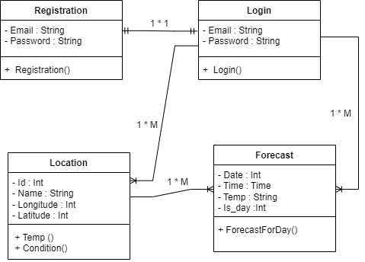

**3.2 Global Use Case Diagram**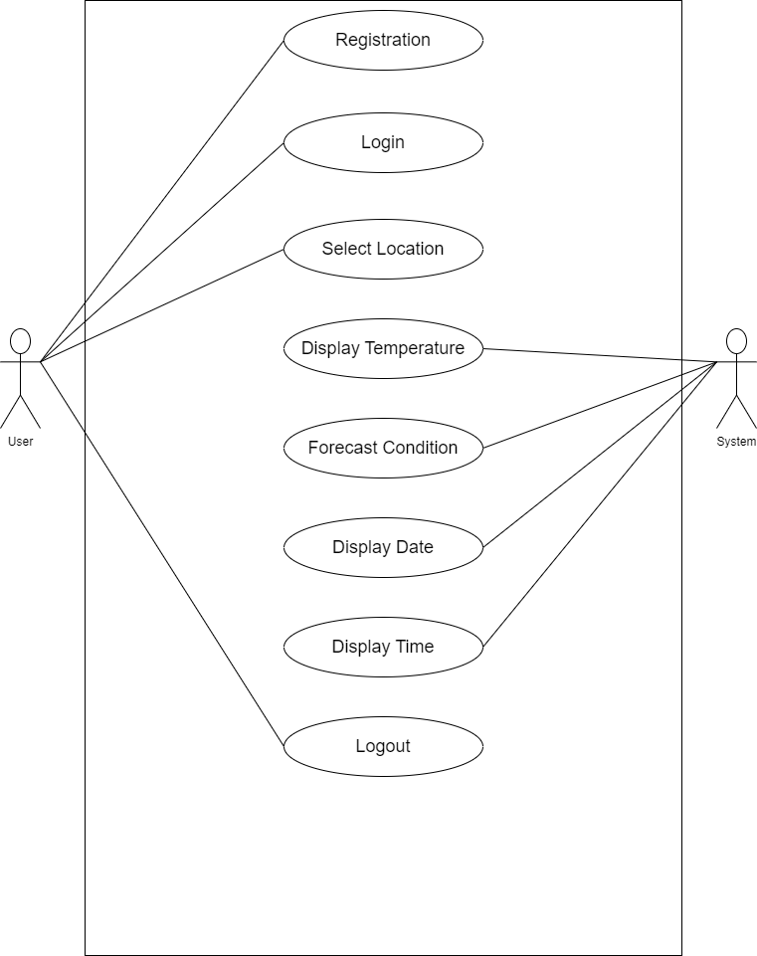

**3.2 Individual Use Case Diagram**

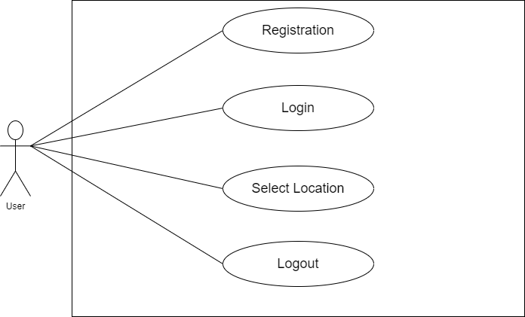

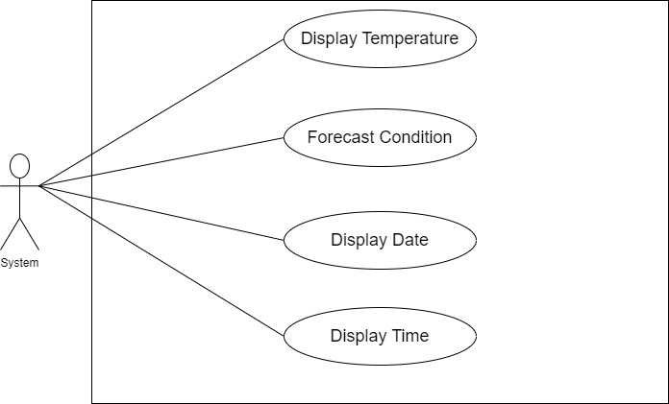

**3.3 Activity Diagram**

* 1. **Sequence Diagram**

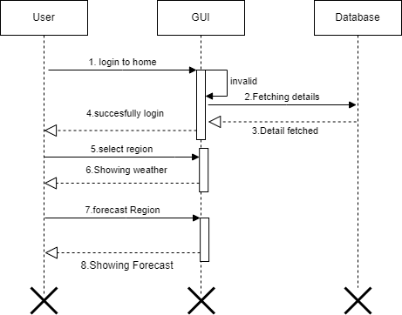

**3.4 Data Dictionary**

|  |  |  |  |  |  |  |  |
| --- | --- | --- | --- | --- | --- | --- | --- |
| **No** | **Data Element** | **Description** | **Data Type** | **Size** | **List of Specific** | **Data Store** | **Remarks** |
| **1** | Email | User Email | Text | 50 | It store user email | Registration Muster | It contains user email |
| **2** | Password | User  Password | Text | 20 | It store user  pwd. | Registration Muster | It contains user pwd |
| **3** | Login | User  Email | Text | 50 | It store user email | Login Muster | It contain user login |
| **4** | Password | User  Pwd | Text | 20 | It store  user pwd | Login Muster | It contains user pwd |
| **5** | Location | Location name | Text | 25 | It store  location | Location Muster | It contains location |
| **6** | Latitude | Latitude | Number | 10 | It store latitude | Location Muster | It contains location latitude |
| **7** | Longitude | Longitude | Number | 10 | It store Longitude | LocationMuster | It contains location longitude |
| **8** | Temperature | Temperature | Number | 50 | It store  Current  temperature | LocationMuster | It contains current temperature |
| **9** | Text | Condition text | Text | 20 | It store text | Location Muster | It contain condition of location |
| **10** | Icon | Condition icon | Image | - | It store cond icon | Location Muster | It contains icon |
| **11** | Date | Date | Number | 50 | It store date | ForecastMuster | It contains date |
| **12** | Time | Time | Number | 50 | It store time | Forecast Muster | It contains time |
| **13** | Temperature | Temperature | Number | 50 | It store  temperature | Forecast Muster | It contains temperature |
| **14** | Is day | day | Date | 20 | It store days | Forecast Muster | It contains week days |
| **15** | Text | Forecast text | text | 50 | It store text | ForecastMuster | It contains forecast |
| **16** | Icon | Forecast icon | image | - | It store image | Forecast Muster | It contains forecast icon |
| **17** | wind | Speed of the wind | Number | 50 | It store wind speed | Forecast Muster | It contain speed of wind |

**3.6Test Procedure And Implementation**

**Unit Testing:**

* **Objective:** Verify the correctness of individual units or components.
* **Implementation:**
  + Test each function or method independently.
  + Use testing frameworks like JUnit for Java.

**Integration Testing:**

* **Objective:** Validate the interactions between different components.
* **Implementation:**
  + Test the integration of frontend components (XML layouts and Java code).
  + Ensure proper communication with backend services (APIs and Firebase).

**User Interface (UI) Testing:**

* **Objective:** Confirm that the user interface is intuitive and visually appealing.
* **Implementation:**
  + Check UI elements for proper alignment and responsiveness.
  + Verify that widgets and maps display correctly.

**Performance Testing:**

* **Objective:** Evaluate the app's responsiveness, speed, and resource usage.
* **Implementation :**
  + Measure app launch time and response to user interactions.
  + Test under different network conditions for data retrieval performance.

1. **USER MANUAL**

**1.Introduction**

**About:**

* Welcome to the Weather Application for accurate and timely weather updates.

**Key Highlights:**

* Real-time updates
* 3 to 7-day forecasts
* Personalized user preferences

**2. Getting Started**

**Installation:**

* Download from Google Play Store.
* Create an account for personalized features.
* Enable location services for accurate forecasts.

**3. UI Tour**

**Home Screen:**

* Current weather and forecasts.

**4. Privacy and Security**

**Privacy Policy:**

* Read our policy on data handling.

**Account Security:**

* Use a strong password and keep it secure.

**Location Data:**

* Used solely for accurate weather information.

**5. Contact and Support**

**Customer Support:**

* Contact [support@weatherapp.com](mailto:support@weatherapp.com) for assistance.

**Feedback:**

* Share your thoughts through in-app feedback.

**5. DRAWBACK AND LIMITATION**

1. **Data Accuracy:**
   * **Drawback:** Weather predictions are subject to change, and occasional inaccuracies may occur.
   * **Limitation:** The app relies on external weather APIs, and real-world conditions may vary.
2. **Limited Location Coverage:**
   * **Drawback:** Some remote or less-populated areas might have limited or less accurate weather data.
   * **Limitation:** The app's accuracy may vary depending on the availability of weather station data in certain regions.
3. **Dependency on Internet Connectivity:**
   * **Drawback:** Real-time weather updates and certain features require an active internet connection.
   * **Limitation:** Users may experience limitations in offline mode, and some features may be restricted.
4. **Device Compatibility:**
   * **Drawback:** Older devices or those with limited resources might experience performance issues.
   * **Limitation:** High-end features such as complex maps may not work optimally on low-spec devices.
5. **Battery Consumption:**
   * **Drawback:** Continuous use of location services and data updates may contribute to increased battery consumption.
   * **Limitation:** Optimizing for low battery usage while providing real-time updates can be challenging.

**6. PROPOSED ENHANCEMENTS**

**1. Android Wear Integration:**

**Proposal:** Develop a companion app for Android Wear devices.

**Enhancement:** Users can receive weather updates directly on their smartwatches, with features like quick glances at current conditions and upcoming forecasts.

**2. Offline Maps and Forecast:**

**Proposal:** Improve offline functionality.

**Enhancement:** Allow users to download maps and weather forecasts for offline use, useful in areas with limited connectivity.

**3. Location-Based Widgets:**

**Proposal:** Introduce location-based widgets.

**Enhancement:** Widgets automatically update based on the user's current location, providing relevant weather information at a glance.

**4. Dark Mode Scheduler:**

**Proposal:** Introduce a dark mode scheduler.

**Enhancement:** Users can set specific times for the app to switch between light and dark modes, reducing eye strain during different parts of the day.

**5. Improved Battery Optimization:**

**Proposal:** Optimize battery usage.

**Enhancement:** Implement efficient background processes and location updates to minimize the impact on device battery life.

1. **USER INTERFACE SCREENS**

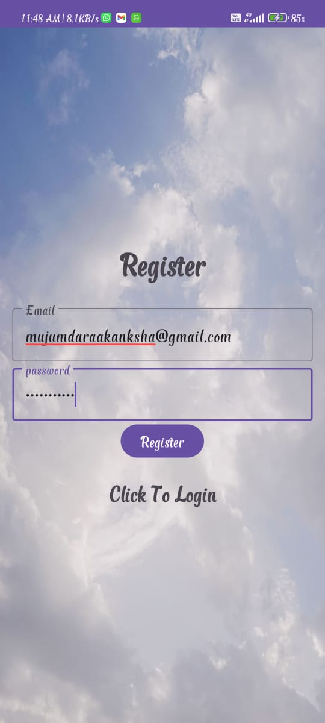

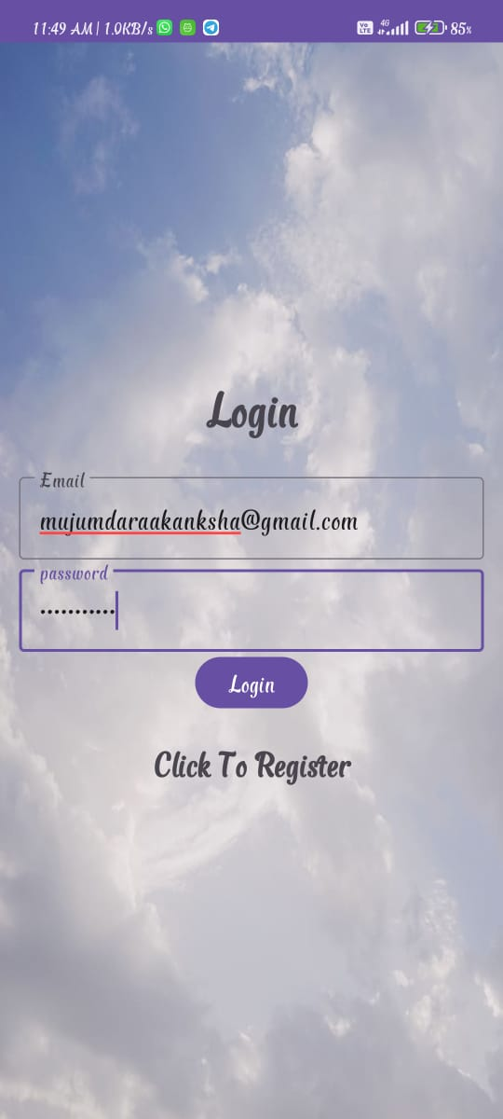

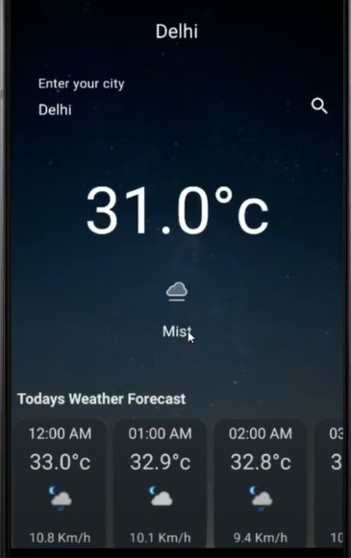

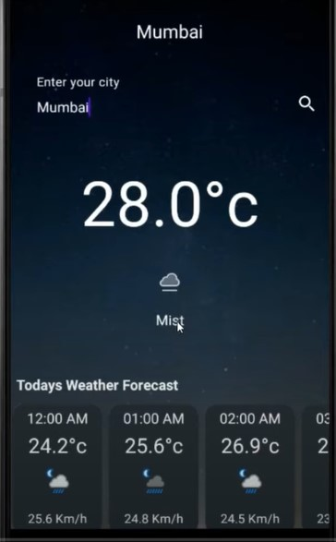

1. **CONCLUSION**

In conclusion, the proposed enhancements for the weather application on Android strive to elevate the user experience, leveraging the capabilities of the Android platform and incorporating modern design principles. These enhancements are designed to make the app more feature-rich, visually appealing, and user-friendly. By addressing key areas such as offline functionality, integration with wearable devices, and improved accessibility, the goal is to meet the diverse needs of Android users and provide a comprehensive weather experience.

The implementation of these enhancements would require close collaboration with Android developers, user interface designers, and weather experts. Regular user feedback, iterative development cycles, and thorough testing would be essential to ensure the successful integration of these features. Additionally, staying abreast of the latest Android technologies and design guidelines will contribute to keeping the app current and competitive in the ever-evolving mobile landscape.

Ultimately, the conclusion emphasizes the commitment to continuous improvement, user satisfaction, and providing a robust and innovative weather application tailored to the Android ecosystem.

**BIBLIOGRAPHY**

* [**https://www.google.com/**](https://www.google.com/)
* [**https://www.weatherapi.com/**](https://www.weatherapi.com/)
* [**https://www.postman.com/**](https://www.postman.com/)
* [**https://developer.android.com/docs**](https://developer.android.com/docs)